# Project Design Phase-I Solution Architecture

|  |  |
| --- | --- |
| Date | 19 September 2022 |
| Team ID | NM2023TMID08418 |
| Project Name | Analytics Tool For Placements |
| Maximum Marks | 4 Marks |

**Solution Architecture:**

Solution architecture is a complex process – with many sub-processes – that bridges the gap between business problems and technology solutions. Its goals are to:

* Find the best tech solution to solve existing business problems.
* Describe the structure, characteristics, behavior, and other aspects of the software to project stakeholders.
* Define features, development phases, and solution requirements.
* Provide specifications according to which the solution is defined, managed, and delivered.

# Example - Solution Architecture Diagram:

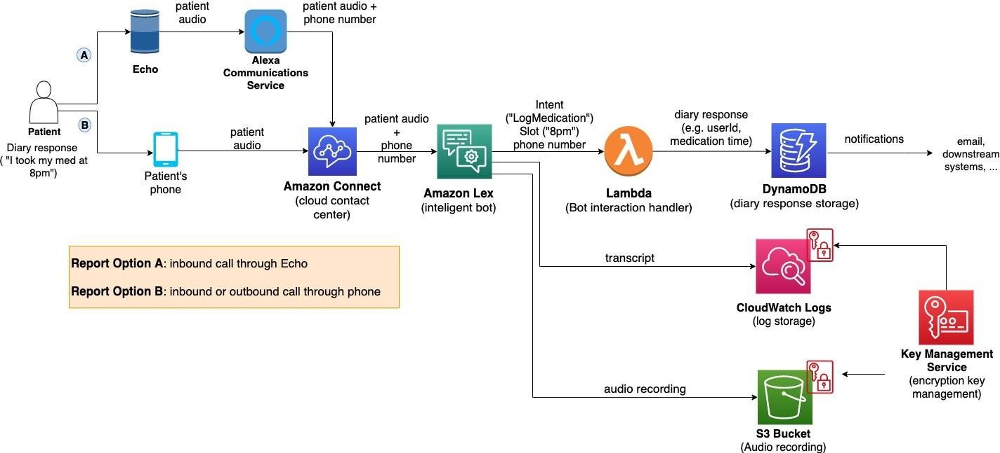

*Figure 1: Architecture and data flow of the voice patient diary sample application*

A robust solution architecture for an analytics tool aimed at enhancing the placements process should be designed with scalability, data integrity, and user-friendliness in mind. Here are the key components and points to consider:

1. **Data Ingestion:**
   * Implement data connectors to gather information from various sources, including job portals, internal databases, and external APIs.
   * Ensure real-time or batch data ingestion based on the availability and update frequency of data sources.
2. **Data Storage:**
   * Utilize a reliable database system (e.g., SQL or NoSQL) to store and organize collected data, ensuring data security and scalability.
   * Implement data warehousing for historical data analysis and reporting.
3. **Data Processing and Analytics:**
   * Employ data transformation and ETL (Extract, Transform, Load) processes to clean and prepare raw data for analysis.
   * Implement advanced analytics tools and algorithms to extract meaningful insights, such as trend analysis, predictive modeling, and recommendation systems.